Abhay Patil Big Data Exam

ID : 240840325002

**HIVE : (20 mrks)**

Q1.

A]

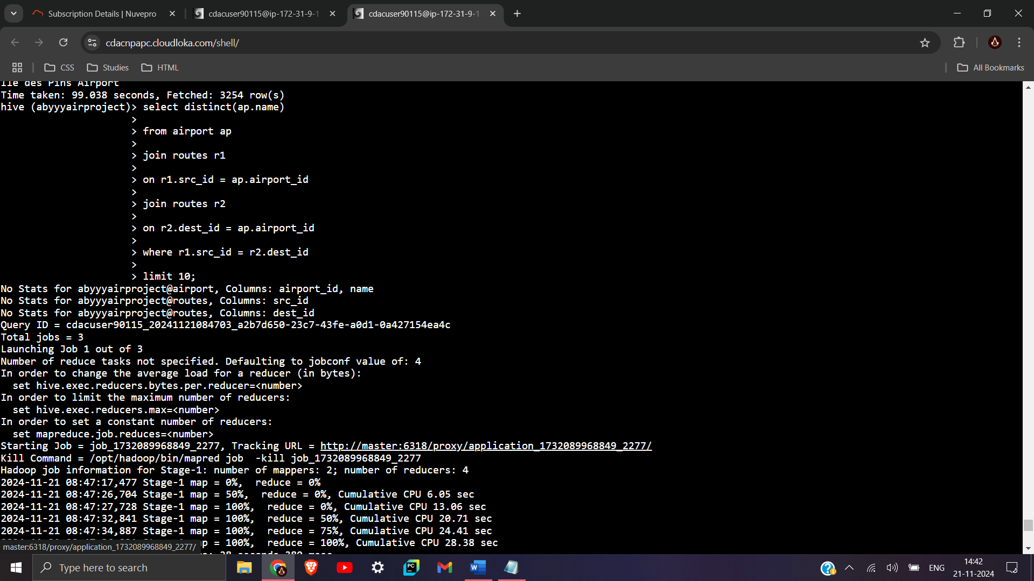

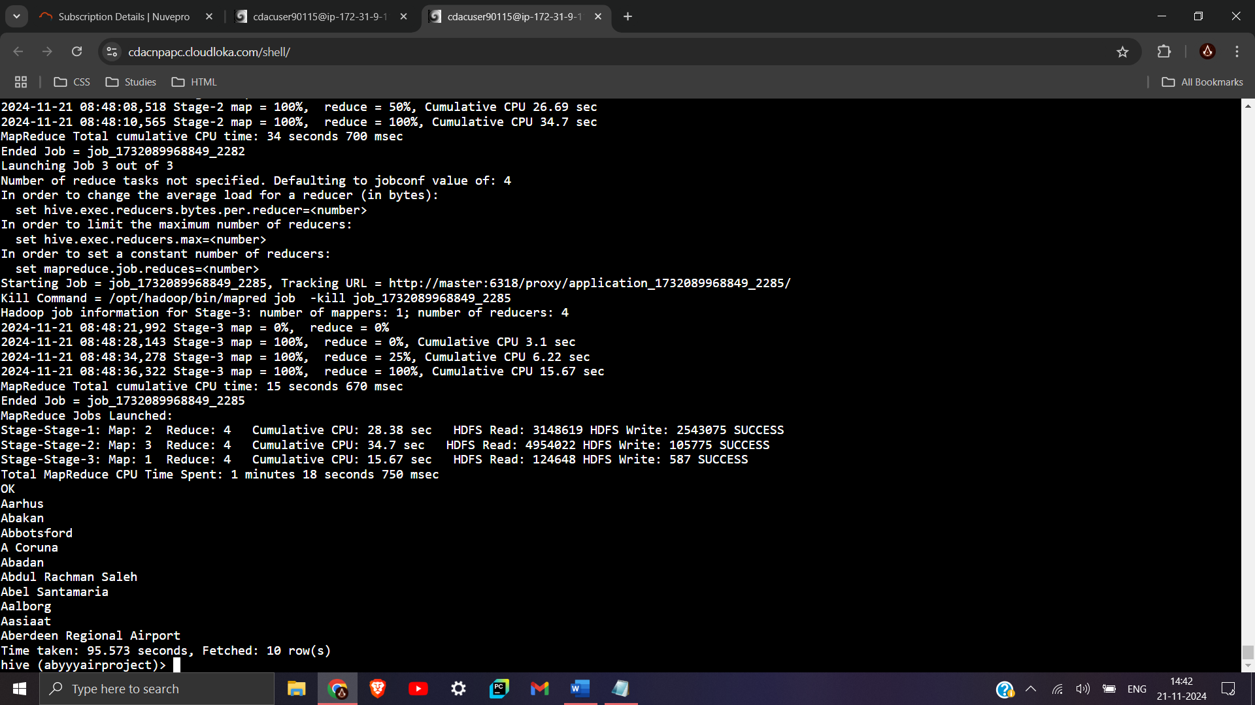

select distinct(ap.name)

from airport ap

join routes r1

on r1.src_id = ap.airport_id

join routes r2

on r2.dest_id = ap.airport_id

where r1.src_id = r2.dest_id

limit 10;

B]

with (select max(equipment) from routes) as man_count,

(select equipment, count(equipment)

from routes

group by equipment

having count(equipment) = max_count);

“Can't get the output due to crashing of the hive terminal.”

C]

select a.name, count(*)

from airlines a

join routes r

on a.airline_id = r.airline_id

group by a.name

having max(count(*)) = count(*);

“Can't get the output due to crashing of the hive terminal.”

Q2.

A]

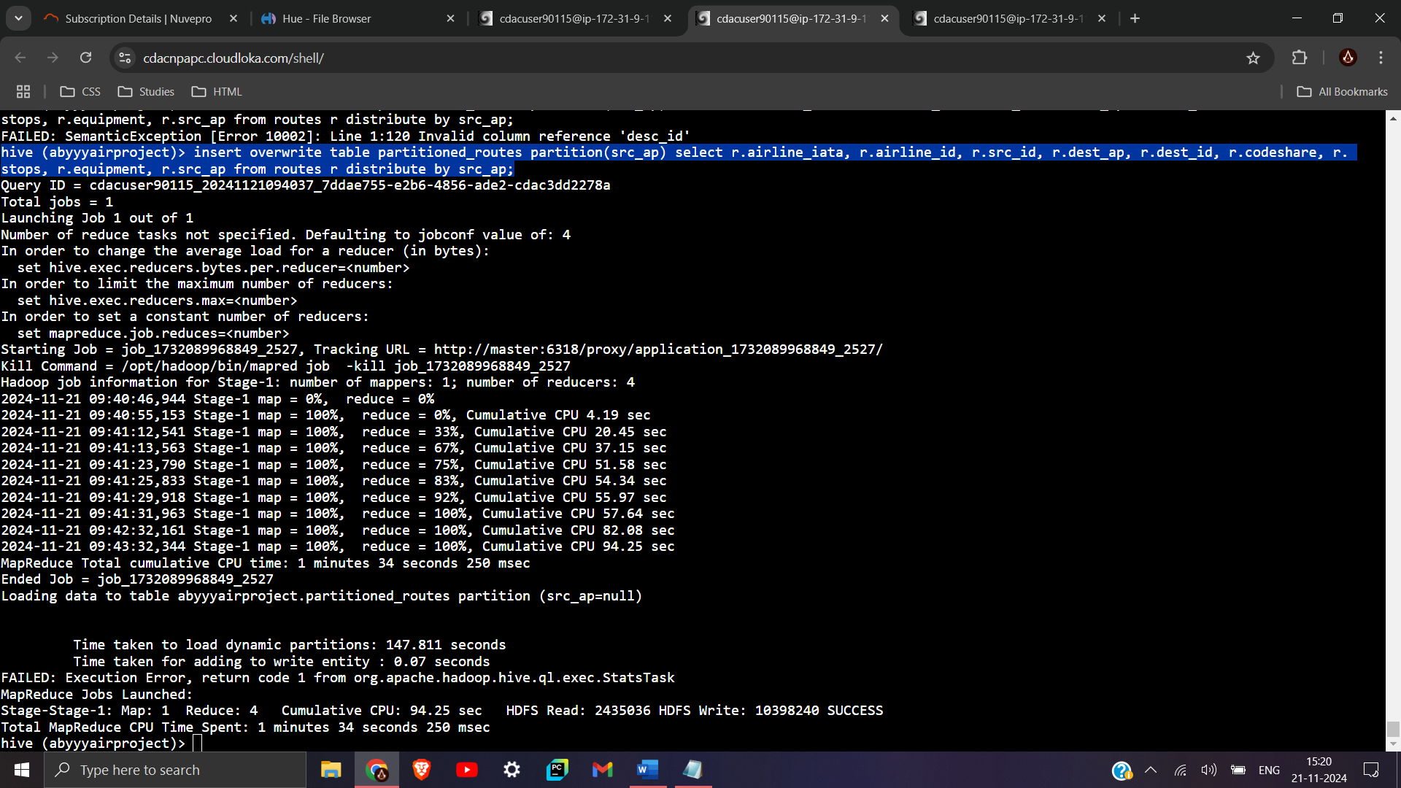

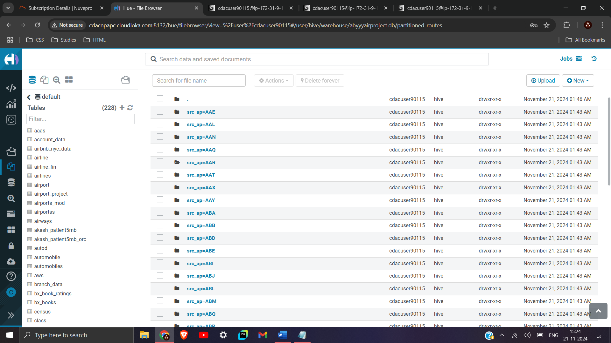

create table partitioned_routes (airline_iata string, airline_id int, src_id int, dest_ap string, dest_id int,

codeshare string, stops int, equipment string)

partitioned by (src_ap string)

row format delimited

fields terminated by ','

stored as textfile;

insert overwrite table partitioned_routes partition(src_ap) select r.airline_iata, r.airline_id, r.src_id, r.dest_ap, r.dest_id, r.codeshare, r.stops, r.equipment, r.src_ap from routes r distribute by src_ap;

B]

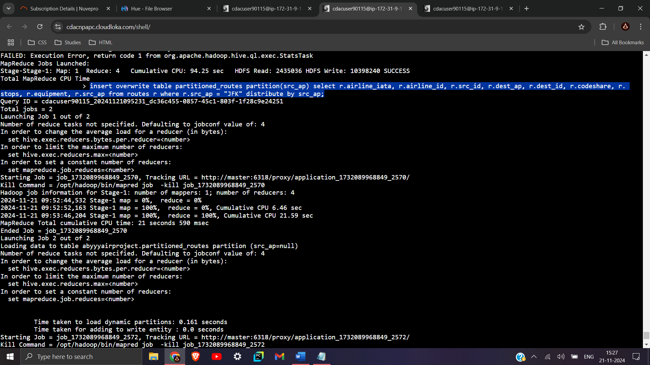

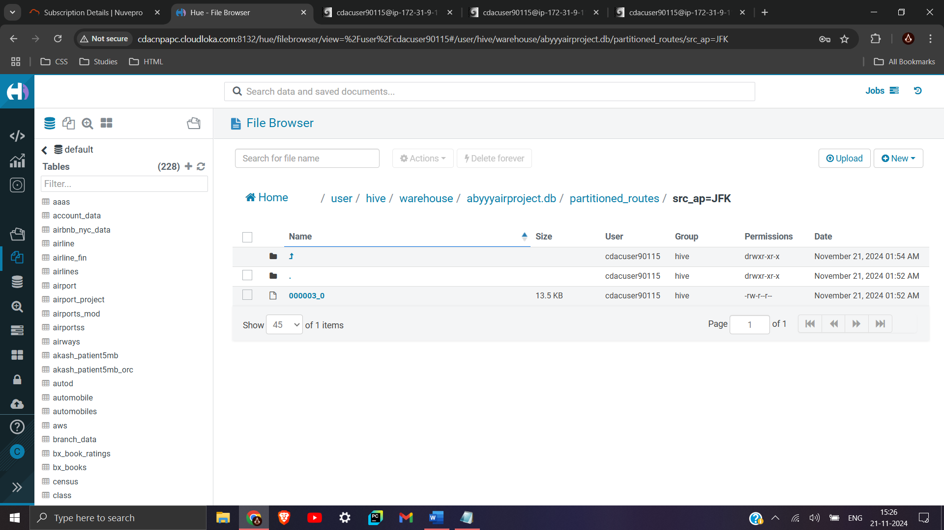

insert overwrite table partitioned_routes partition(src_ap) select r.airline_iata, r.airline_id, r.src_id, r.dest_ap, r.dest_id, r.codeshare, r.stops, r.equipment, r.src_ap from routes r where r.src_ap = "JFK" distribute by src_ap;

C]

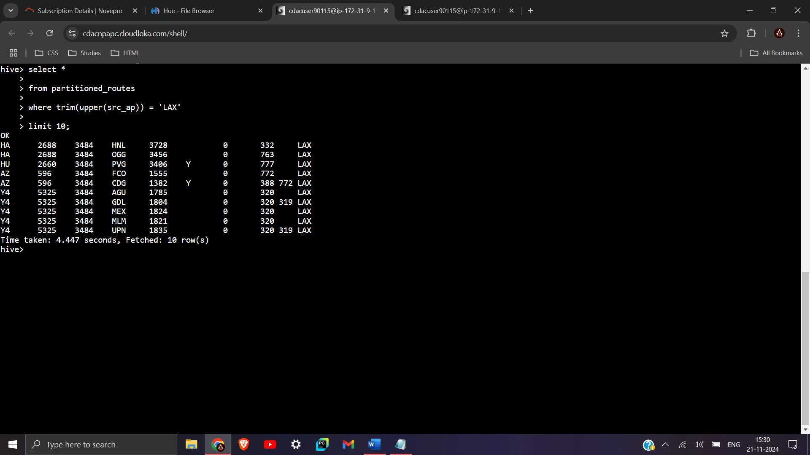

select *

from partitioned_routes

where trim(upper(src_ap)) = 'LAX'

limit 10;

D]

**SPARK : (20 mrks)**

**Q1.**

**A]**

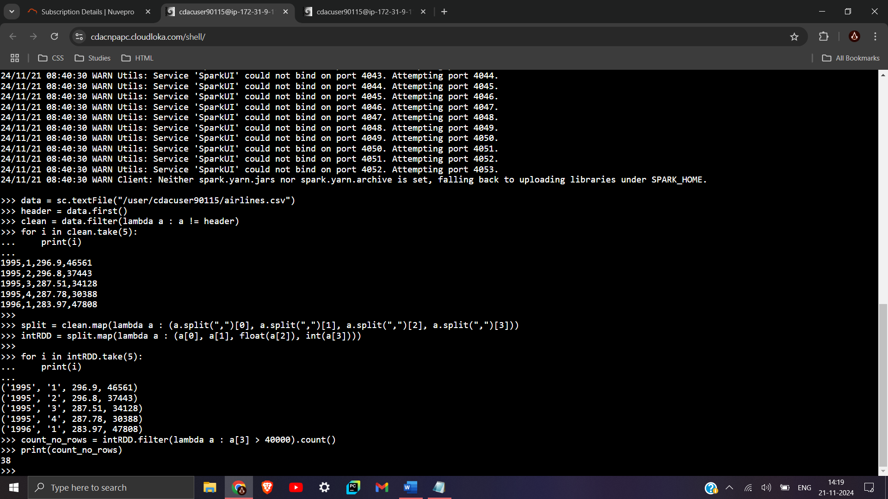

>>> count_no_rows = intRDD.filter(lambda a : a[3] > 40000).count()

>>> print(count_no_rows)

B]

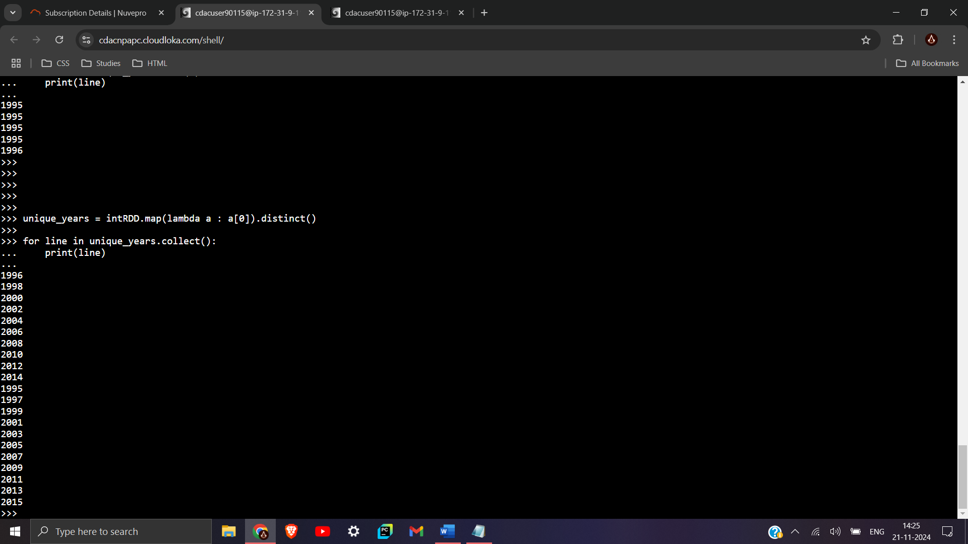

>>> unique_years = intRDD.map(lambda a : a[0]).distinct()

>>>

>>> for line in unique_years.collect():

... print(line)

Q2.

A]

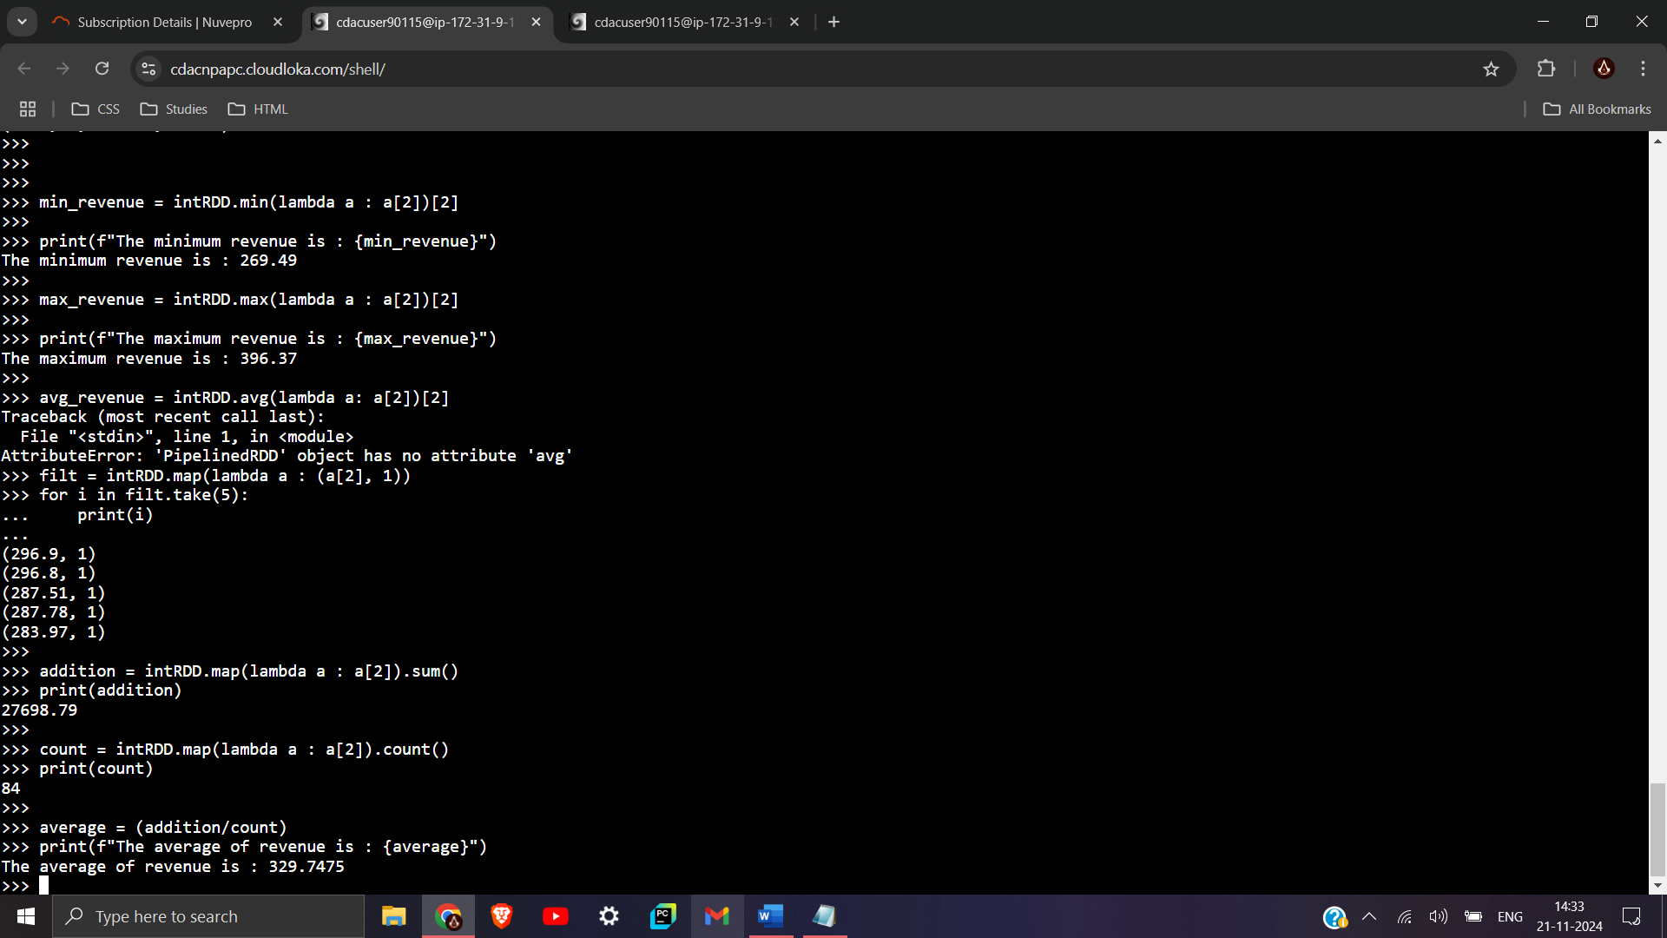

>>> min_revenue = intRDD.min(lambda a : a[2])[2]

>>>

>>> print(f"The minimum revenue is : {min_revenue}")

The minimum revenue is : 269.49

>>>

>>> max_revenue = intRDD.max(lambda a : a[2])[2]

>>>

>>> print(f"The maximum revenue is : {max_revenue}")

The maximum revenue is : 396.37

>>> addition = intRDD.map(lambda a : a[2]).sum()

>>> print(addition)

27698.79

>>>

>>> count = intRDD.map(lambda a : a[2]).count()

>>> print(count)

84

>>>

>>> average = (addition/count)

>>> print(f"The average of revenue is : {average}")

The average of revenue is : 329.7475

B]

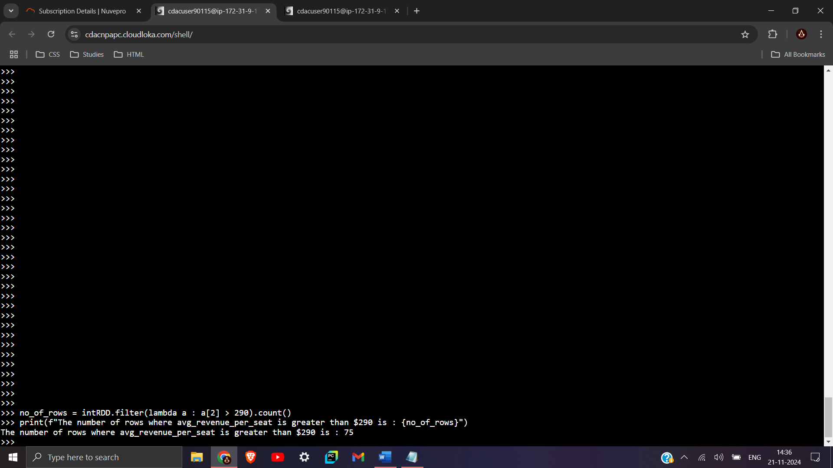

>>> no_of_rows = intRDD.filter(lambda a : a[2] > 290).count()

>>> print(f"The number of rows where avg_revenue_per_seat is greater than $290 is : {no_of_rows}")

The number of rows where avg_revenue_per_seat is greater than $290 is : 75

C]

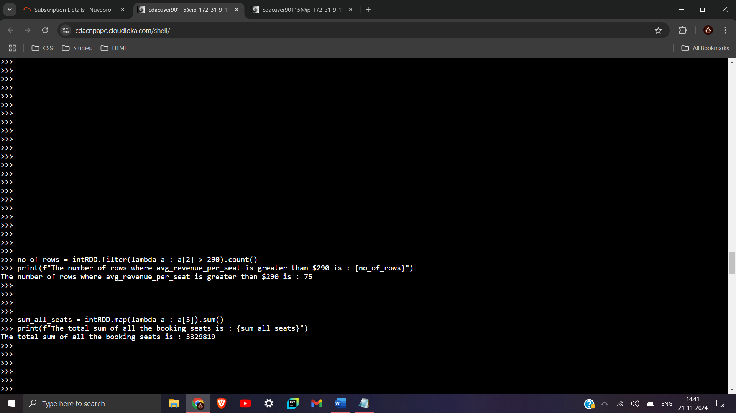

>>> sum_all_seats = intRDD.map(lambda a : a[3]).sum()

>>> print(f"The total sum of all the booking seats is : {sum_all_seats}")

The total sum of all the booking seats is : 3329819

D]

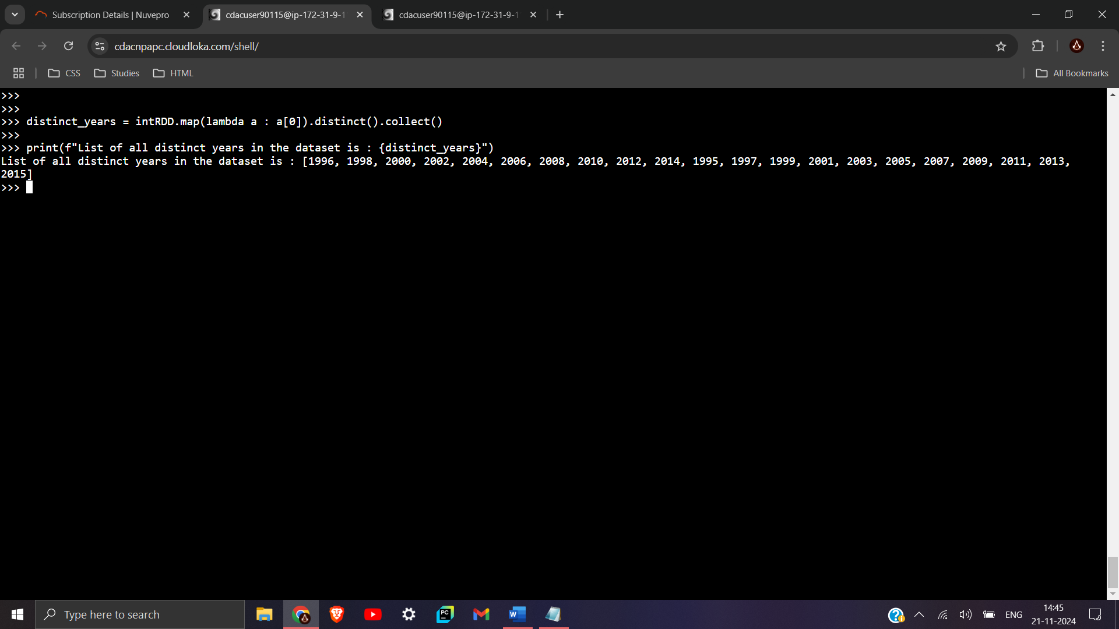

>>> distinct_years = intRDD.map(lambda a : a[0]).distinct().collect()

>>>

>>> print(f"List of all distinct years in the dataset is : {distinct_years}")

List of all distinct years in the dataset is : [1996, 1998, 2000, 2002, 2004, 2006, 2008, 2010, 2012, 2014, 1995, 1997, 1999, 2001, 2003, 2005, 2007, 2009, 2011, 2013,

2015]

E]

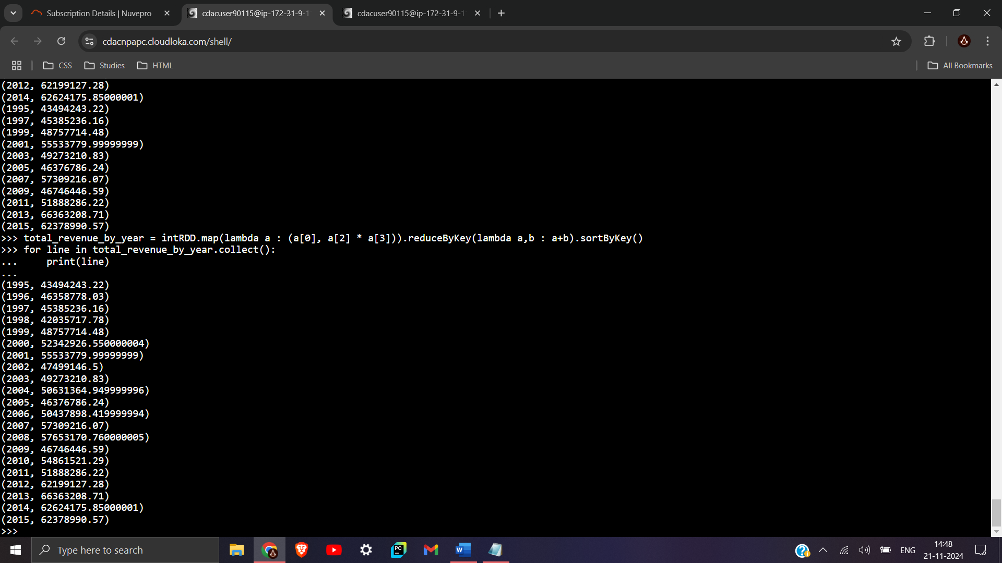

>>> total_revenue_by_year = intRDD.map(lambda a : (a[0], a[2] * a[3])).reduceByKey(lambda a,b : a+b).sortByKey()

>>> for line in total_revenue_by_year.collect():

... print(line)

...